LAB 3
TASK 1:
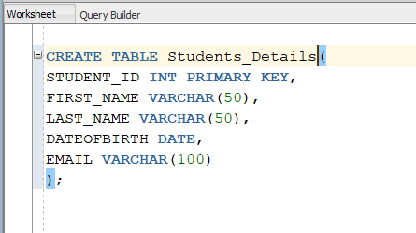
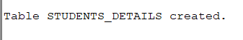
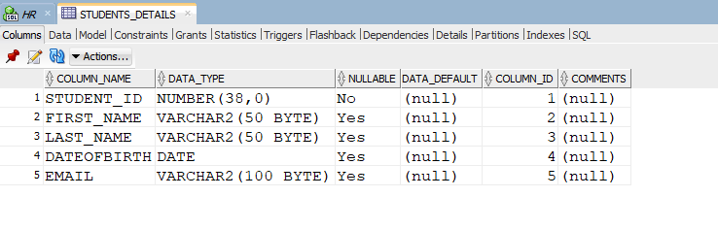
TASK 2:
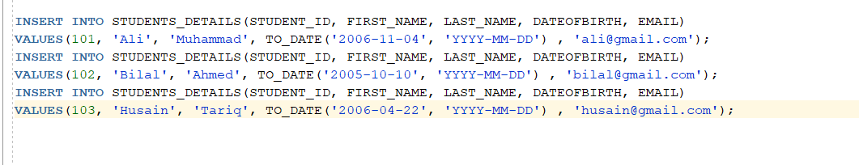
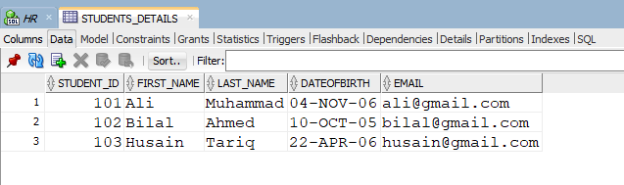
TASK 3:

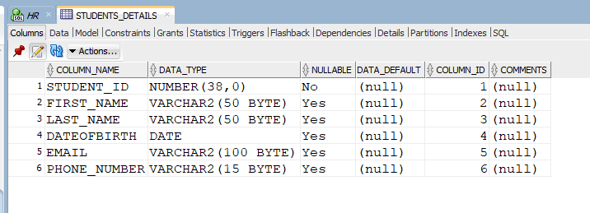

TASK 4:
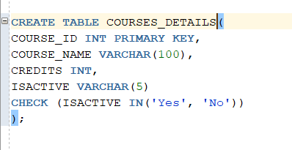
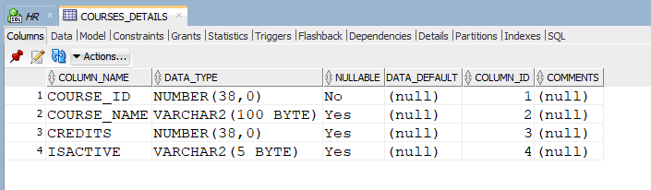
TASK 5:
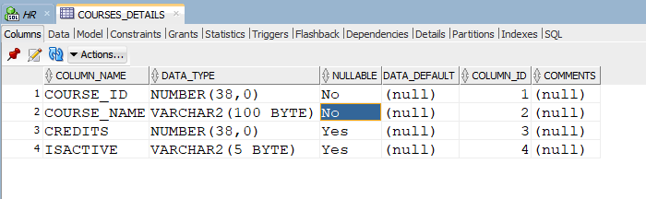

TASK 6:
Reason for error:
Because one table can have only one primary key.
TASK 7:
- 